**Creating a Node**

**-**

**Red UI to view**

**data**

**in**

**Separate**

**Graphical**

**form**

Date

10

November

2022

Team

ID

PNT2022TMID

1

0394

Project

Name

Gas

Leakage

Monitoring

and

Alerting

System

for

Industries.

**After creating the Node Red Web**

**Application,**

**we**

**have**

**to**

**install**

**the**

**UI**

**interface**

**in**

**Node**

**Red.**

○

Copy

and

pasting

the

URL

of the

NodeRed

in the new

tab

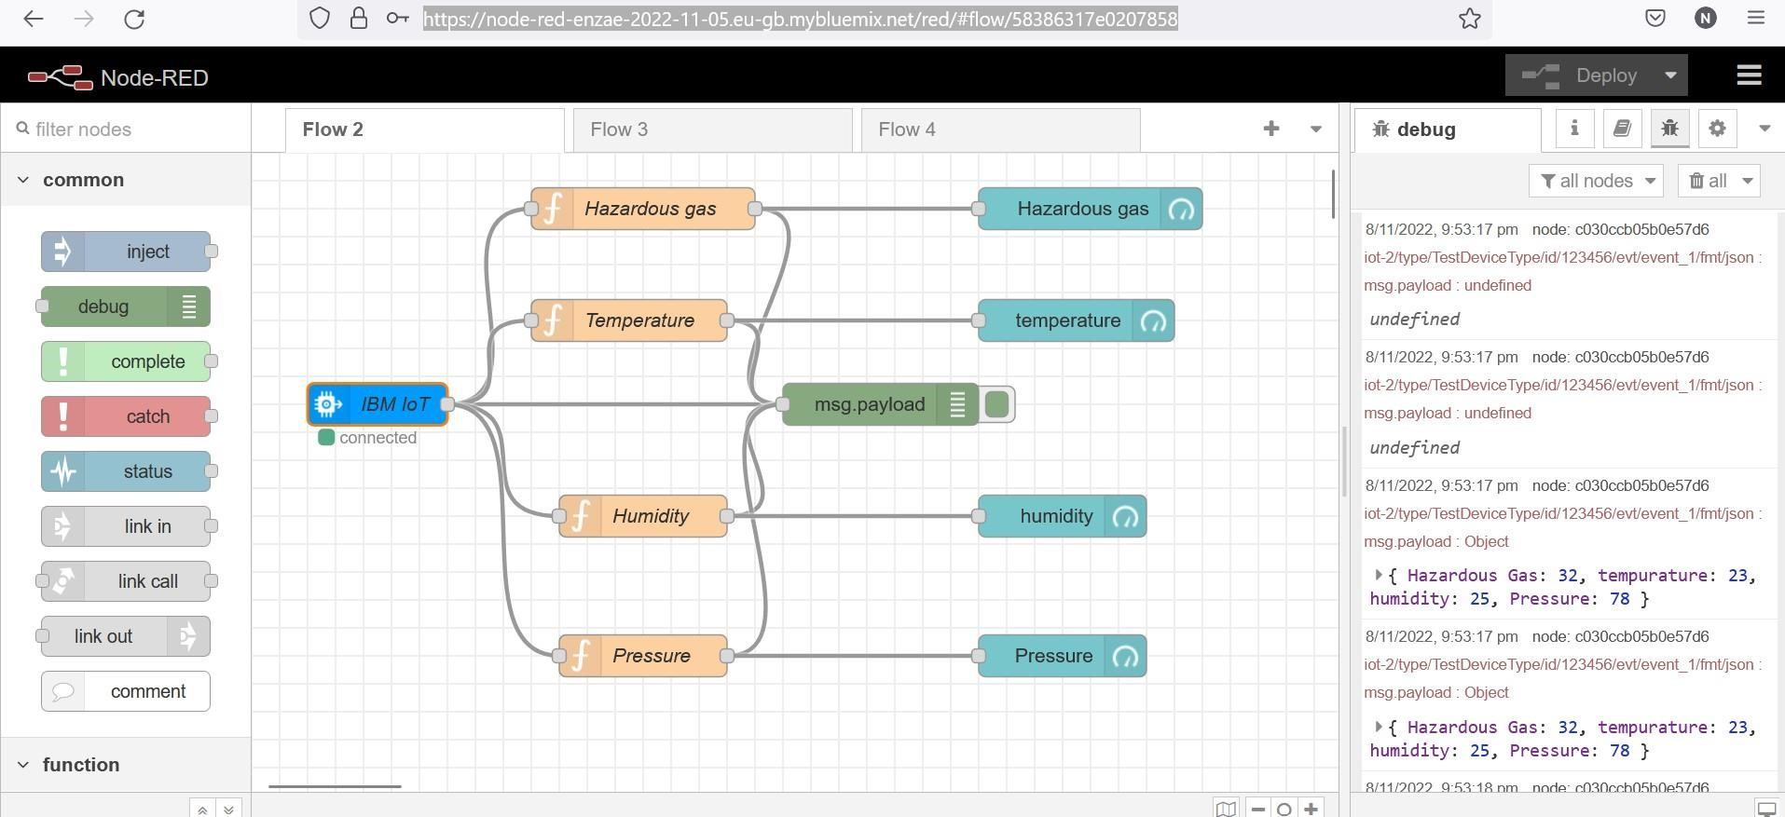

Output :

Link:

https://node

-

red

-

zuoid

-

2022

-

11

-

10

.eu

-

gb.mybluemix.net/ui/#!/0?socketid=gC8tvX

-

RJ4EFGRjTAAAL

**Result:**

Thus,

the Node

Red

UI

is

created

successfully.

